**1) Monitoring well in front of the Civil Engineering Building**

Coordinates: 33°35'12.7"N 101°52'25.5"W

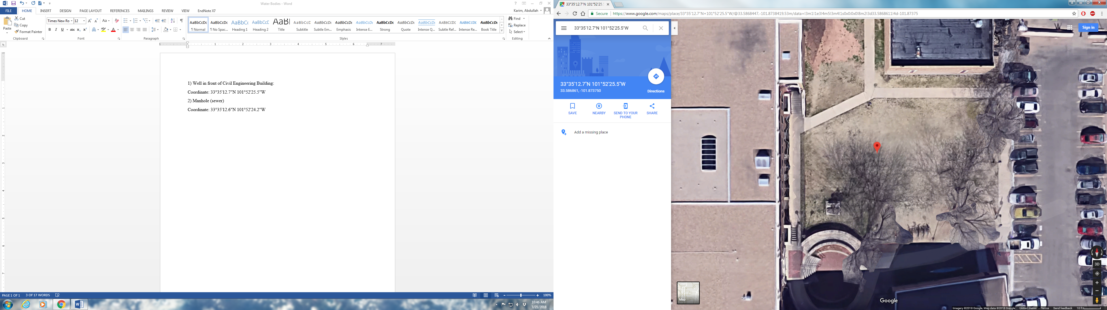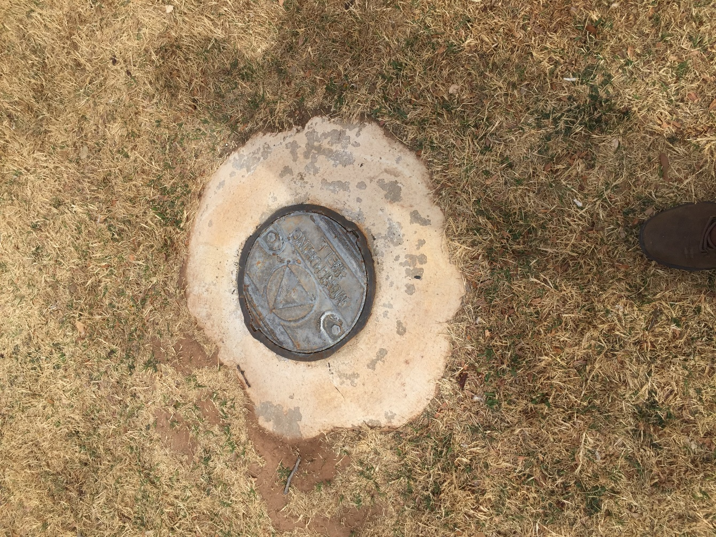

**2) Pipes coming out of the Civil Engineering Building**

Coordinates: 33°35'11.8"N 101°52'26.1"W

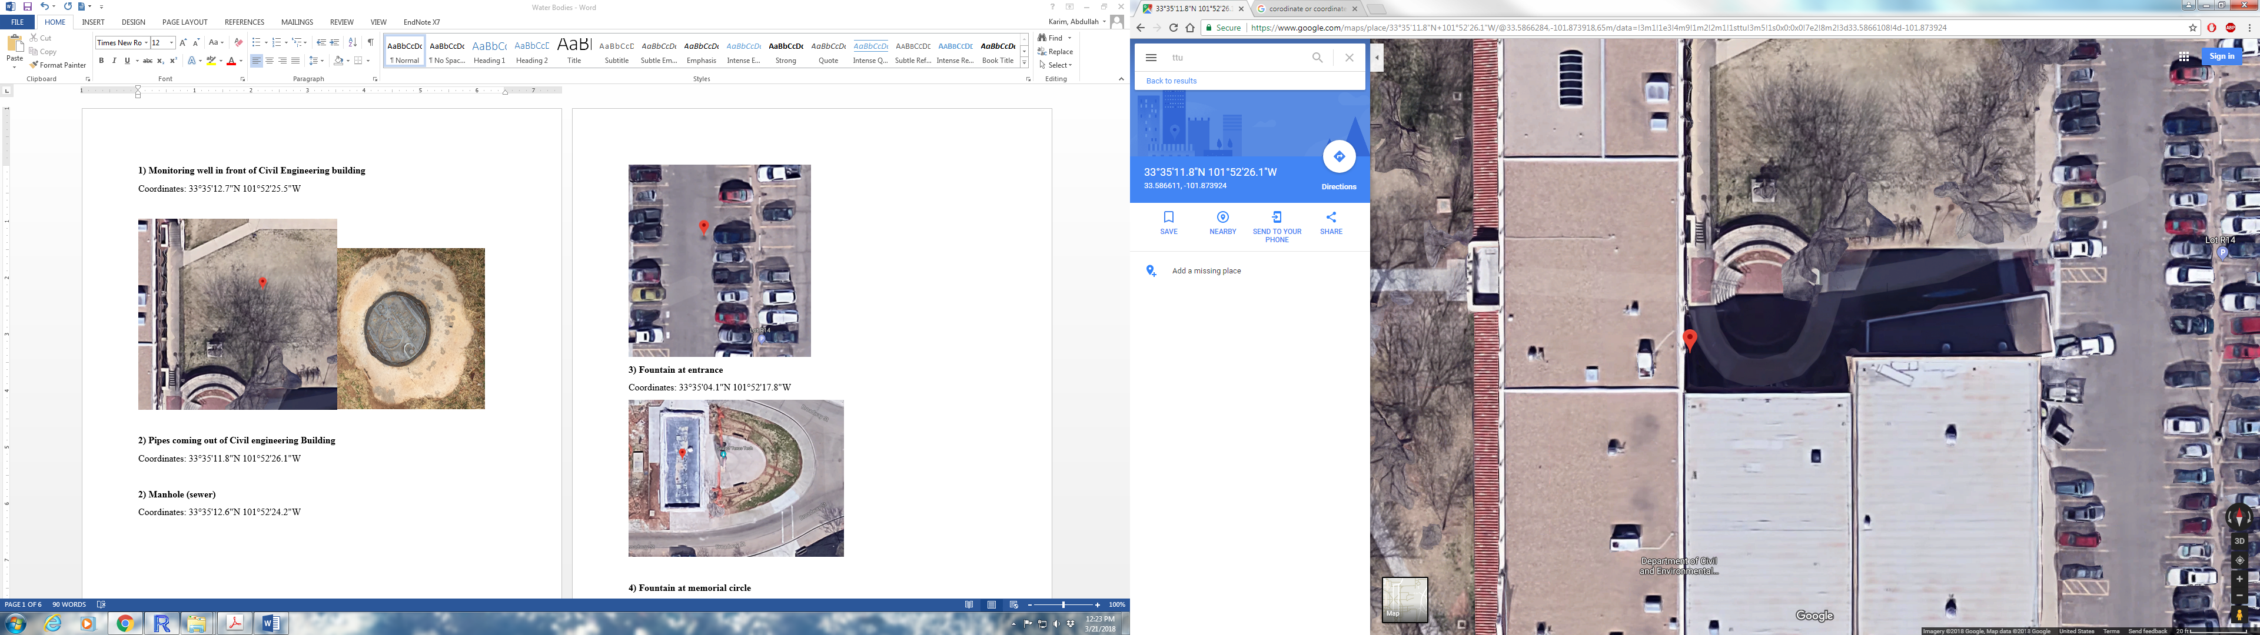 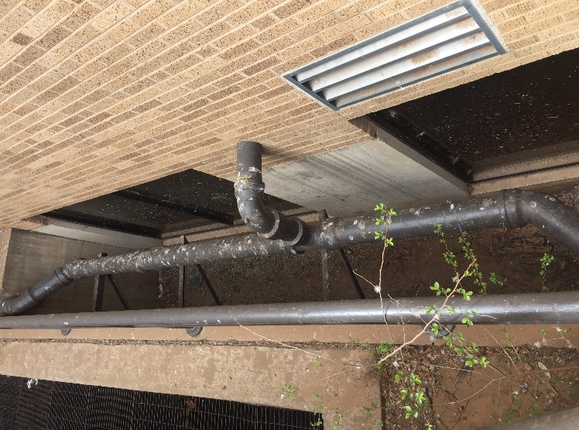

**3) Manhole (sewer) at Lot R14 in front of the Civil Engineering Building**

Coordinates: 33°35'12.6"N 101°52'24.2"W

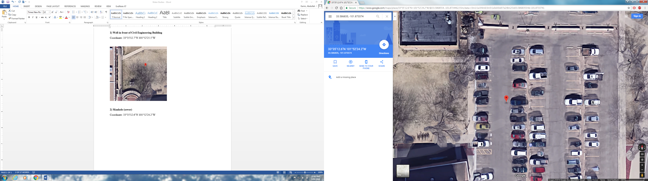

**4) Fountain at entrance**

Coordinates: 33°35'04.1"N 101°52'17.8"W

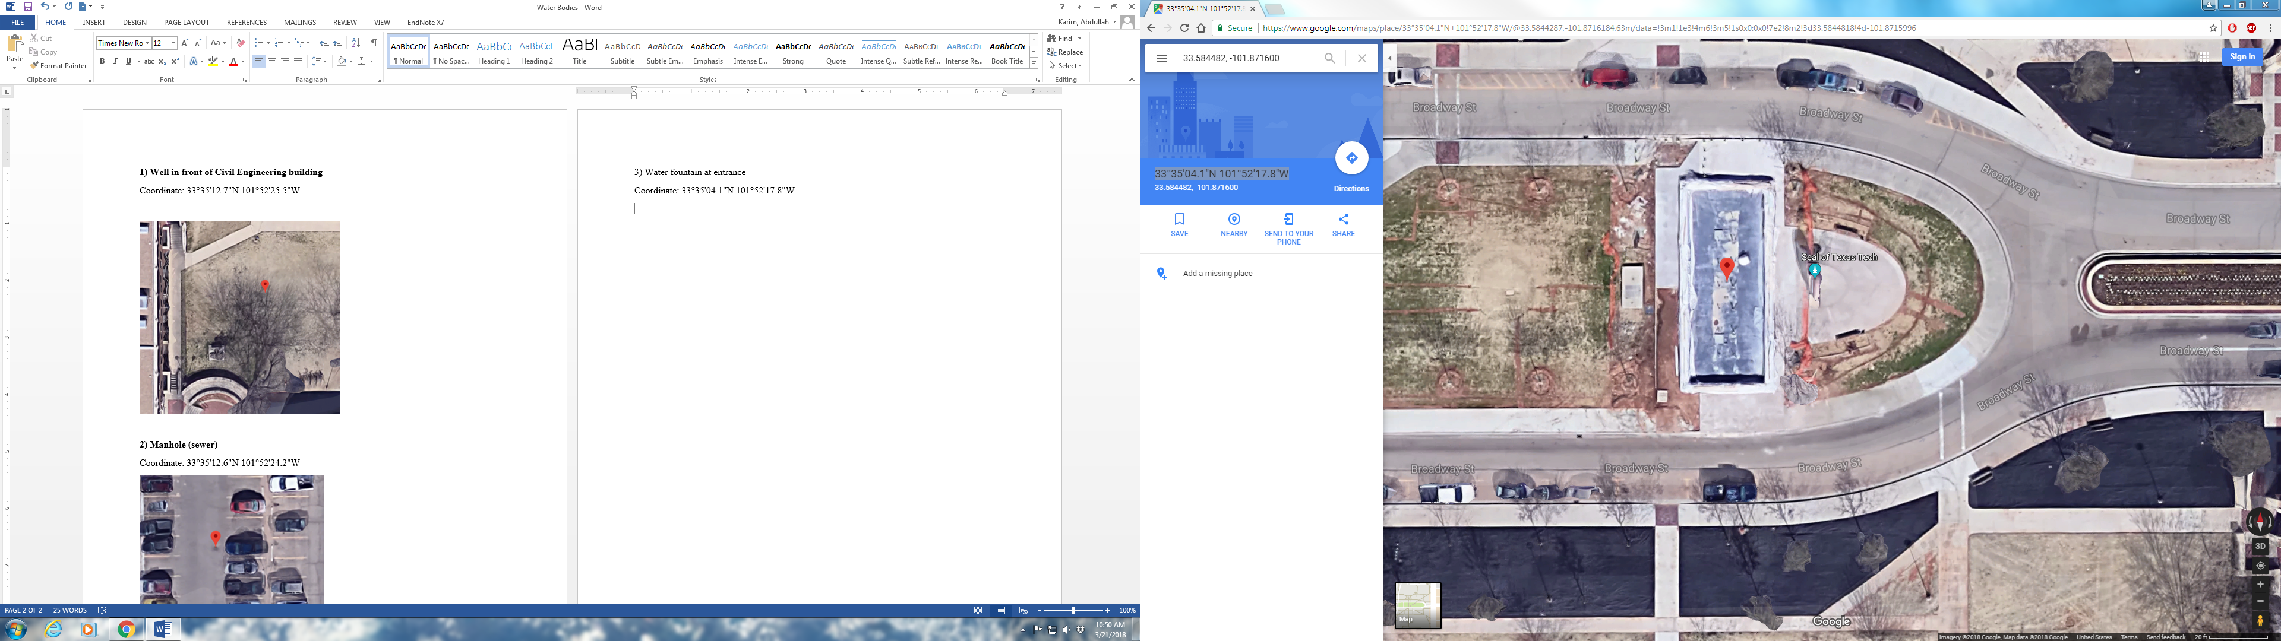

**5) Fountain at memorial circle**

Coordinates: 33°35'04.1"N 101°52'28.3"W

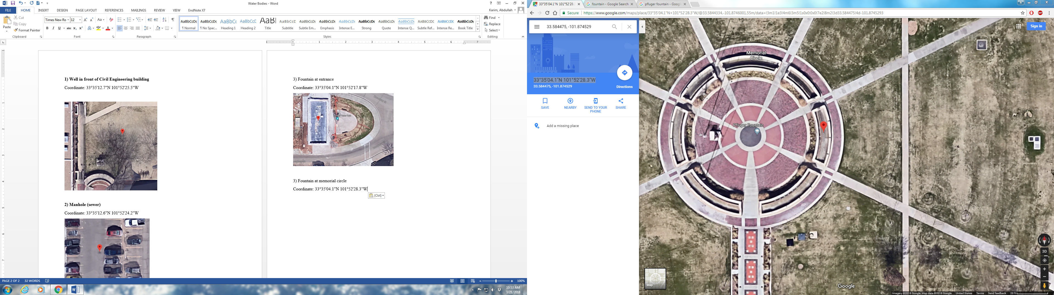

**6)** **Fountain in the Holden Hall**

Coordinates: 33°35'07.6"N 101°52'25.9"W

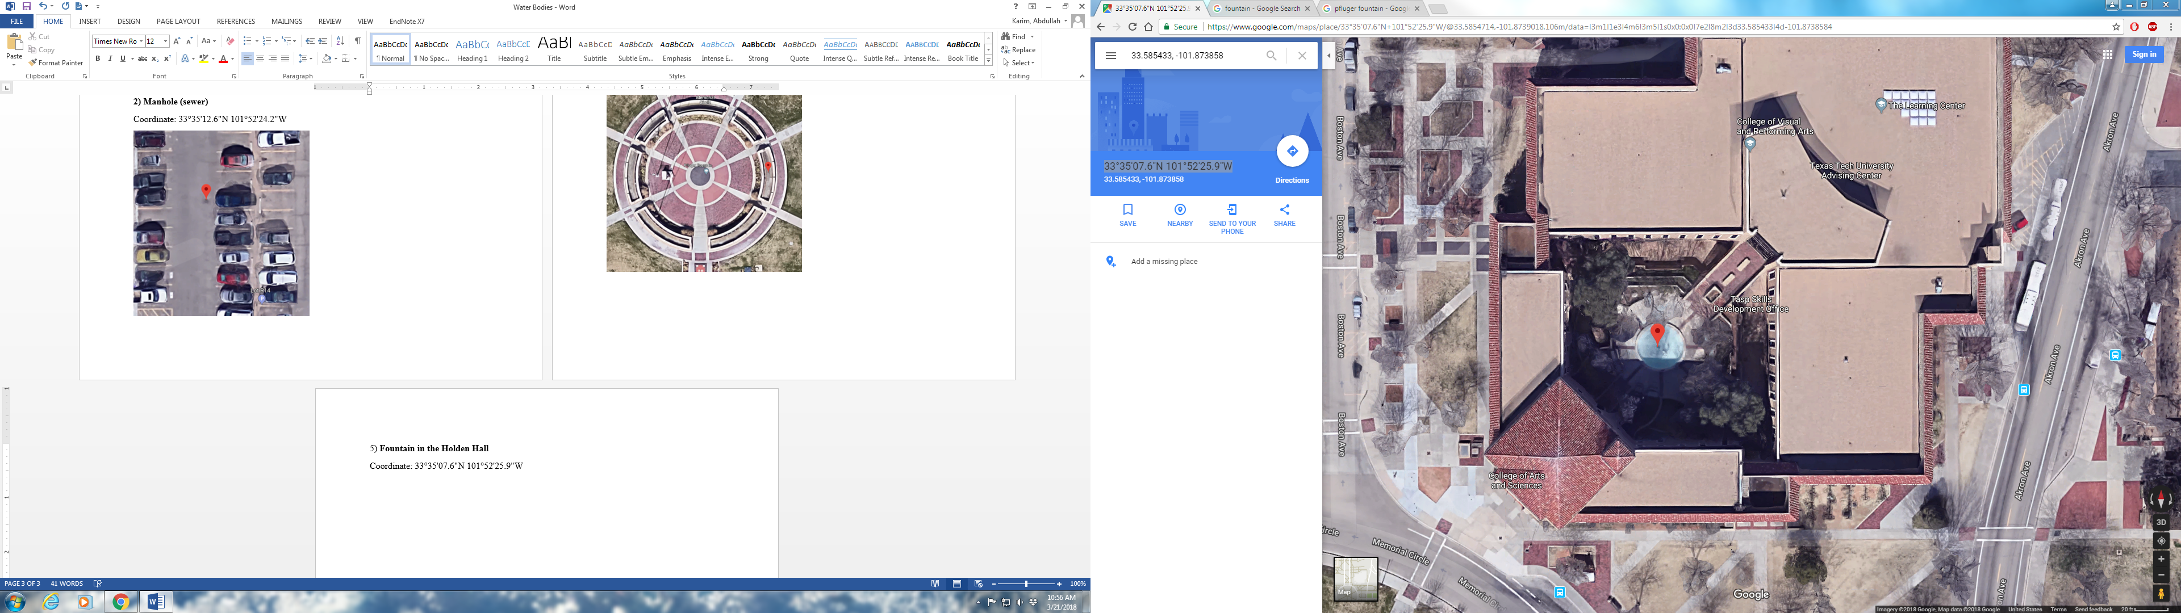

**7)** **Fountain-1 at the library**

Coordinate: 33°34'53.6"N 101°52'37.6"W

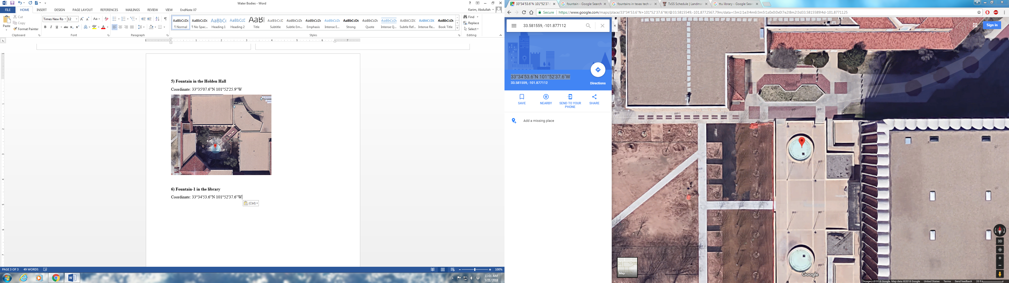

**8)** **Fountain-2 at the library**

Coordinates: 33°34'52.5"N 101°52'37.6"W

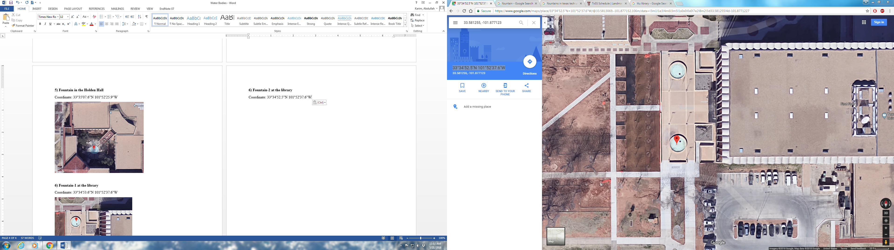

**9)** **Fountain in front of the English Department**

Coordinates: 33°34'51.1"N 101°52'45.3"W

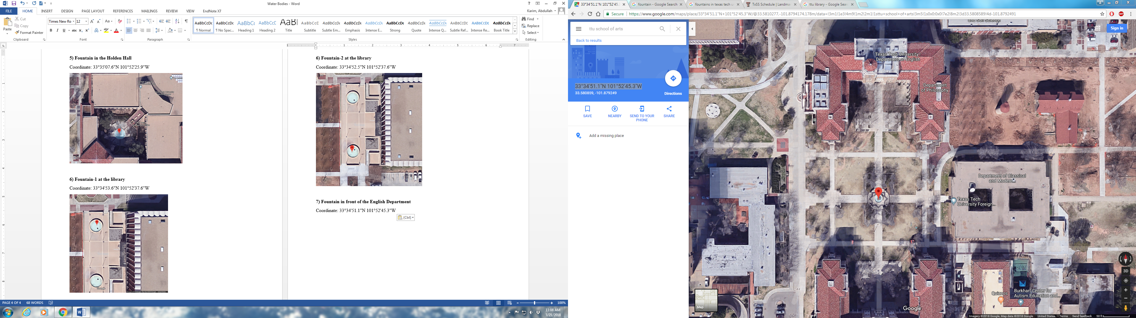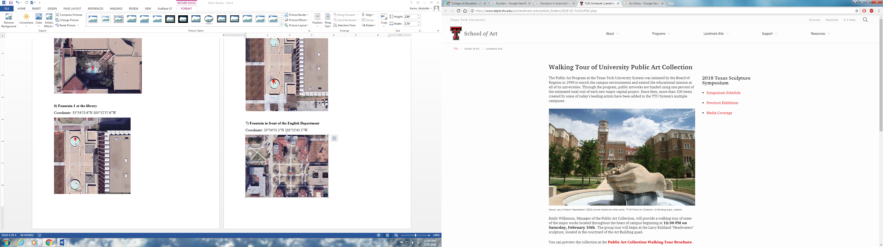

**10)** **Pond at** **Urbanovsky Park, Flint Avenue**

Coordinates: 33°34'51.5"N 101°52'58.3"W

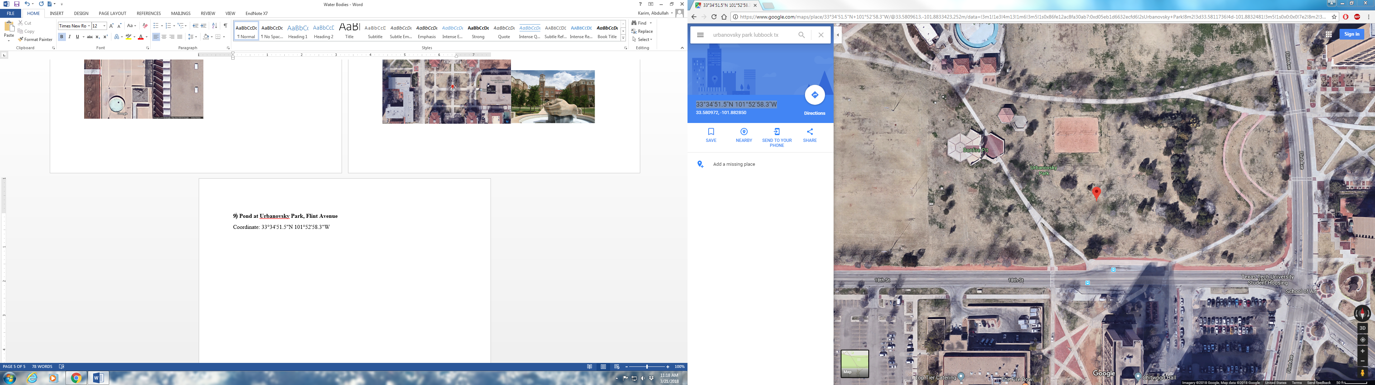

**11)** **Drain pipe coming out of Flint garage**

Coordinates: 33°34'45.6"N 101°52'53.2"W

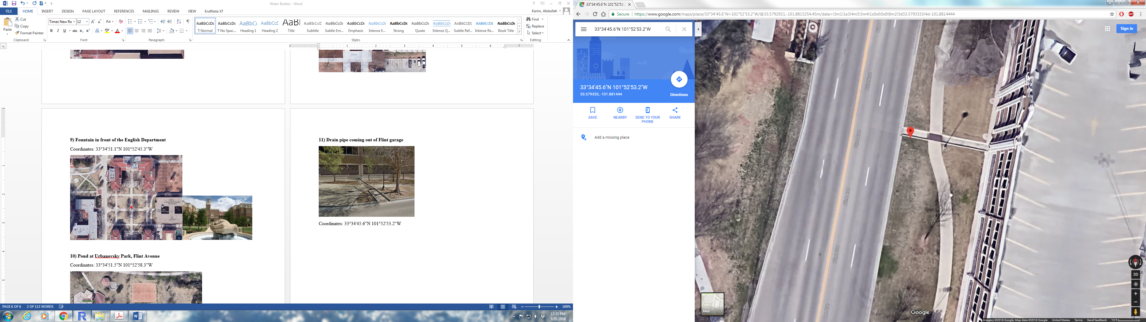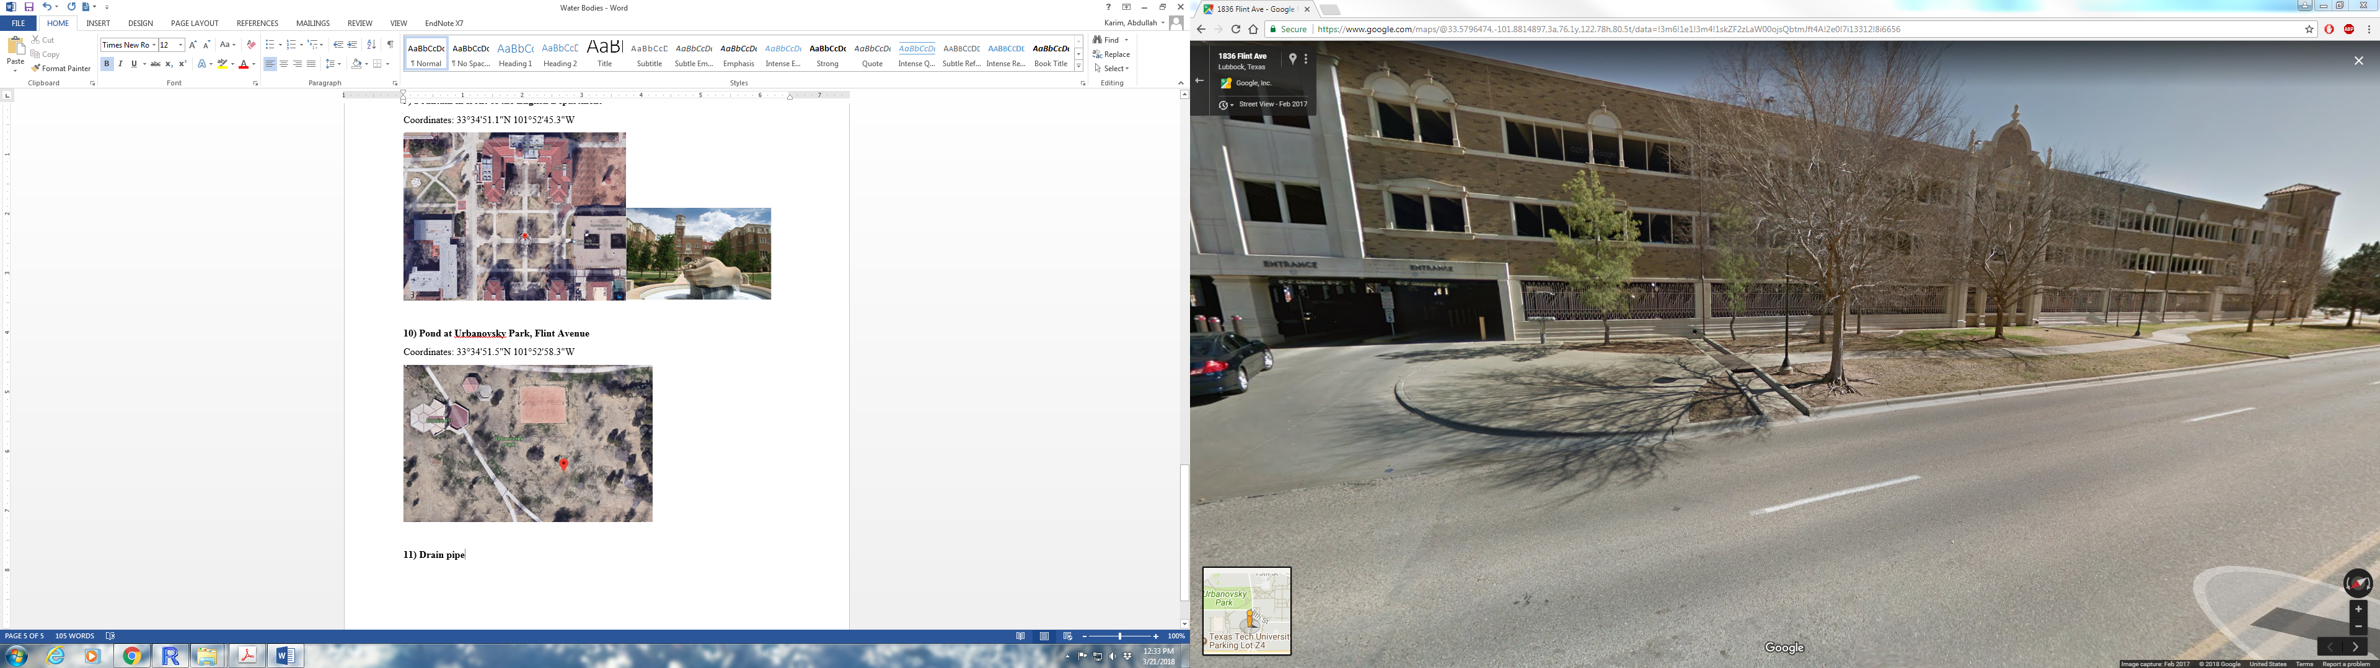

Credits: Photos are taken from Google Maps, TTU website and self-taken